­­­­­­

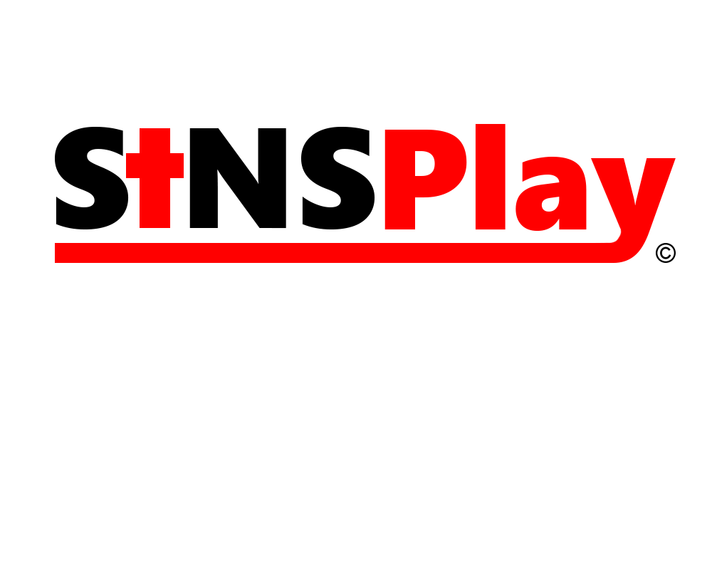

**APPLICATION FOR PART TIME**

**UNITY GAME DEVELOPER**

*Incomplete Applications will not be accepted.*



Email Phone Number

__________________________________________________________________________________________________________

